**Mechi Multiple Campus**

**Tribhuvan University**

**Institute of Science and Technology**

**A Project Proposal On**

**“Emotion Based Music Recommendation System”**

In Partial Fulfilment of Requirements for the Bachelor Degree in Computer Science and Information Technology

**Under the supervision of:**

Mr. Narayan Dhamala

**Submitted to:**

Department of Computer Science and Information Technology

Mechi Multiple Campus

Jhapa, Nepal

**Submitted by:**

Saugat Adhikari (24567/076)

Saugat Chapagain (24568/076)

Saugat Gautam (24569/076)

**Date:2024-03-15**

**Mechi Multiple Campus**

**Tribhuvan University**

**Institute of Science and Technology**

**Supervisor’s Recommendation**

I hereby recommend that this project prepared under my supervision by **Saugat Gautam, Saugat Chapagain, Saugat Adhikari** entitled **“Emotion Based Music Recommendation System”** in partial fulfillment of the requirements for the degree of Bachelor of Science in Computer Science and Information Technology is recommended for the final evaluation.

………………………

Mr. Narayan Dhamala

Project Supervisor

Mechi Multiple Campus

Bhadrapur, Jhapa

**Mechi Multiple Campus**

**Tribhuvan University**

**Institute of Science and Technology**

**CERTIFICATE OF APPROVAL**

The undersigned certify that they have read and recommended to the Department of Computer Science and Information Technology, IOST, Mechi Multiple Campus, a project report entitled **“Emotion Based Music Recommendation System”** submitted by **Saugat Adhikari, Saugat Chapagain, Saugat Gautam.** The Project was carried out under special supervision and within the time frame prescribed by the syllabus. We found the students to be hardworking, skilled and ready to undertake any related work to their field of study and hence we recommend the award of partial fulfilment of Bachelor’s degree of Computer Science and Information Technology.

|  |  |
| --- | --- |
| **Signature of the Supervisor** | **Signature of the HOD/Coordinator** |
| **Signature of the External Examiner** | **Signature of the Internal Examiner** |

**ACKNOWLEDGEMENT**

The satisfaction of completion of this project work will be incomplete without mentioning the people responsible for the venture. We are thankful to our prestigious institution **MECHI MULTIPLE CAMPUS** which has provided us a congenial environment and surrounding to work in. We are grateful to our Coordinator **Mr. Saroj Nepal**, Department of B.Sc. CSIT, M.M.C for providing us with all elite facilities for academic purpose. We express our sincere thanks to sir, **Mr. Narayan Dhamala**, His encouragement, invaluable technical support and assistance throughout the entire project have been of immense help in realizing this Project work. His guidance gave us the environment to enhance our knowledge, skills and to reach the pinnacle with sheer determination, dedication and hard work. We extend our thanks to the entire faculty of the Department of B.Sc. CSIT, M.M.C, Bhadrapur, who have encouraged me throughout the course of entire presentation. We also extend my thanks to lab instructors, non-teaching staff, librarian, friends and family members for their continuous support during the course.

**Project Members:**

Saugat Adhikari [24567/076]

Saugat Chapagain [24568/076]

Saugat Gautam [24569/076]

**Abstract**

The Emotion Based Music Recommendation System is an inventive project that integrates emotional intelligence into its recommendation algorithms with the goal of completely changing how we listen to and find music. The goal of this project is to provide users with individualized and emotionally relevant music suggestions by utilizing the emotional power of music, a universal medium that elicits a wide range of emotions. The system makes use of advanced machine learning (ML) and artificial intelligence (AI) techniques to precisely evaluate and comprehend the emotional undertones of different musical compositions as well as the emotional states of its users. The listener's overall experience is improved by using these data to produce music recommendations that correspond with their current emotional state. This project aims to fill the gap in the market by providing personalized music recommendations that take into account not only the listener's listening history or musical tastes, but also the emotional context of the song. The concept distinguishes itself from traditional recommendation algorithms by entering the relatively unexplored field of emotion-driven music discovery. Convolution Neural Networks (CNNs), Content-Based Filtering, and Collaborative Filtering are some of the approaches that will be used in the implementation plan. It's important to remember, nevertheless, that the precise methods and approaches to be employed may change depending on the demands of the project, the data that is accessible, and the level of complexity that is required. To develop a solution that carefully takes into consideration users' emotional states, it is necessary to integrate a number of different algorithms and techniques into an emotion-based music recommendation system. By using a multidimensional approach, our system makes recommendations based on emotional intelligence, ensuring that users may enjoy a more engaging and richer experience with music discovery.

**Keywords:** Artificial Intelligence, Collaborative Filtering, Convolution Neural Network, Machine Learning.

**Table of Contents**

CHAPTER-1 1

Introduction 1

1.1. Introduction 1

1.2. Problem Statement 2

1.3. Objectives 2

1.4. Scope 2

1.5. Limitations 3

1.6. Development Methodology 3

CHAPTER-2 4

Background Study and Literature Review 4

2.1. Background Study 4

2.2. Literature Review 4

CHAPTER-3 6

System Analysis 6

3.1 Requirement collection and Analysis 6

3.1.1 Functional Requirements 6

3.1.2. Non-Functional Requirements 7

3.2 Feasibility Analysis 8

3.2.1 Technical Feasibility 8

3.2.2 Operational Feasibility 8

3.2.3 Economic Feasibility 9

3.2.4 Schedule 9

CHAPTER-4 10

System Design 10

4.1 System Design 10

4.1.1 Class Diagram 10

4.1.2 Object Diagram 10

4.1.3 State Diagram 11

4.1.4 Sequence Diagram 12

4.1.5 Activity Diagram 12

4.2 Algorithm details 13

4.2.3 Integration of CNNs and Collaborative Filtering 14

CHAPTER-5 15

Implementation and Testing 15

5.1 Implementation 15

5.1.1 Data Set Collection 15

5.1.2 Code Implementation 15

5.1.3 Data Tables 17

5.1.4 Tools Used 18

5.2 Testing 19

5.3 Types of Testing 19

5.3.1 Unit Testing 19

5.3.2 System Testing 20

CHAPTER-6 21

Conclusion and Future Recommendation 21

6.1 Conclusion 21

6.2 Future Recommendation 21

References 22

APPENDIX 23

**List Of Figures**

Figure 1:Iterative Waterfall Model 3

Figure 2:Use Case Diagram 7

Figure 3:Gantt Chart 9

Figure 4:Class Diagram 10

Figure 5:Object Diagram 11

Figure 6:State Diagram 11

Figure 7:Sequence Diagram 12

Figure 8:Activity Diagram 13

Figure 11: Emotion Data 16

Figure 12: Music Data 17

Figure 13:Home Page 24

Figure 14:Start Page 24

Figure 15:Music Recommendation Page 25

Figure 16:About Us Page 25

**List Of Table**

Table 1: Music_Table.csv 18

Table 2: Emotion_Table.csv 18

Table 3:Unit Testing 20

Table 4: System Testing 21

**List of Abbreviation**

**Abbreviation Definition**

CASE Computer-Aided Software Engineering

CNN Convolution Neural Network

CSS Cascading Style Sheets

HTML Hypertext Markup Language

IDE Integrated Development Environment

# CHAPTER-1

# Introduction

## Introduction

Emotion Based Music Recommendation System is a computer-based tool which aims to transform how we find and enjoy music by integrating emotional intelligence into the recommendation system. People frequently use their facial expressions to express their emotions. People's moods have traditionally been known to change in response to music. The ability to identify the emotion that a person is expressing, as well as play music that fits the user's mood, can gradually ease the user's anxiety and have a pleasant overall impact. The project's aim to use a person's facial expressions to convey their emotions. A webcam interface on computer systems is used in the construction of a music player to record human emotion. The software takes a video image of the user, then uses image segmentation and processing algorithms to extract elements from the target person's face and attempt to identify the emotion that the person is attempting to express. By playing music that fits the user's preferences and presenting the user's image, the action seeks to enhance the user's mood. Facial expression recognition has been the most advanced kind of expression analysis since the beginning of humankind. Facial expressions are the finest means by which people may understand or interpret the emotion, sentiment, or concept that another person is attempting to express.

Emotion based music recommendation system has the potential to have a huge influence on artificial intelligence, machine learning, and user experience design as well as the field of music recommendation. In order to fully understand the emotions expressed in songs, we used collaborative filtering to examine the emotional content of lyrics and music recordings. The system is designed using neural networks, which are a kind of deep learning algorithms, to improve the recommendation system even further. This system helps user to find and listen music according to their emotion. On listening to the music based on their emotion, they can find similar music.

## Problem Statement

Music recommendation system frequently doesn’t take into account the emotional content of music, which leads to suggestions that could not be in line with consumers' emotions and moods. The recommendation system faces the challenge of predicting how users will react to different content and suggesting the most suitable items for each individual. Some other problem statements are:

* The classification of songs according to user expectations.
* The music suggestion based on user music preferences.

Traditional music recommendation systems frequently depend on metadata or user behavior data, but they are unable to sufficiently express the emotional depth of music. Personalized music recommendation systems are necessary because of the powerful emotional influence that music has on listeners. These systems should address the following elements.

## Objectives

The Emotion-Based Music Recommendation System project's main goal is to create a modern, user-focused music discovery platform that uses sophisticated algorithms and artificial intelligence to deliver individualized music suggestions based on users' emotional states. The objectives of the project are:

* To improve user satisfaction and engagement by providing music based on user preference.
* To provide straightforward data that has quick access which meet user expectation.

## Scope

An emotion-based music recommendation system's scope includes a number of features meant to improve user pleasure, engagement, and experience. The recommendation techniques have been widely used across multiple fields and sectors, such as social media and online platforms. Users can find interesting and relevant music to match their interests because of the music recommendation system. Some of the scope of emotion-based music recommendation using neural network and content-based filtering algorithm are:

* It provides models for expressing the emotional qualities of musical material including rhythm, melody and lyrics.
* It can be used to provide the recommendation of new music according to the category.

## Limitations

The following are some of the limitations of emotion-based music recommendation system:

* Recommendation systems face difficulties in identifying and interpreting the complex emotional states of users.
* The system may not provide songs based on user current emotional state.
* The system relies on emotional states of user, so without proper emotional data the accuracy of the system may be compromised.
* Cold start problem.

## Development Methodology

This project is developed by using iterative waterfall model. It is the basic principle of waterfall model. In this model, each phase is still completed sequentially, but after each phase, there is a feedback loop that allows for revisiting and refining previous work before moving on to the next phase. This iterative approach helps to uncover and address issues early in the development process, leading to more flexible and adaptable software.

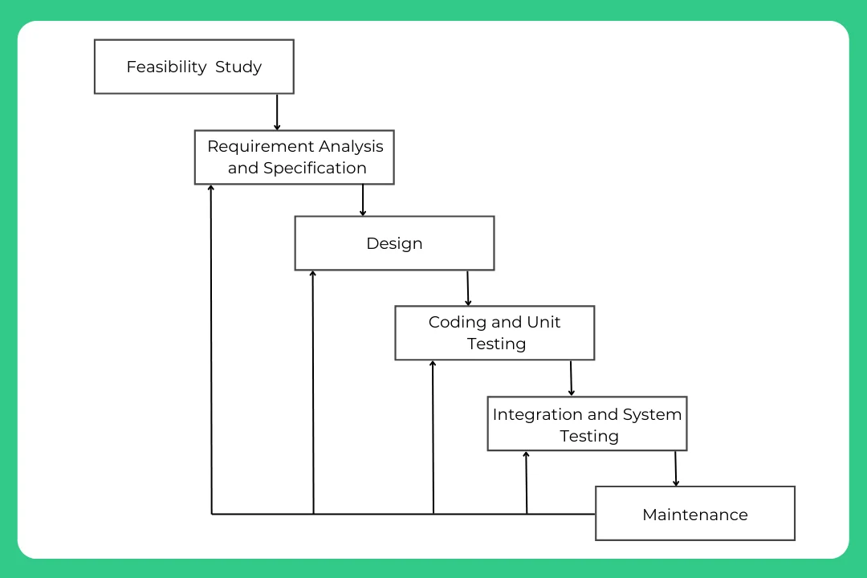

Figure 1:Iterative Waterfall Model

# CHAPTER-2

# Background Study and Literature Review

## 2.1. Background Study

The integration of neural networks and content-based filtering algorithms in emotion-based music recommendation systems is an innovative approach to improving user pleasure and engagement with music platforms. By using techniques such as sentiment analysis, audio feature extraction, and user modelling, these systems seek to identify users' emotional states and provide tailored music suggestions. For increased recommendation accuracy, hybrid techniques that combine neural networks with content-based filtering algorithms take advantage of user interaction data as well as characteristics found in music content. Cross-cultural viewpoints, privacy concerns, and evaluation criteria all influence how these systems are developed and put into use. Real-world case studies steer future research in this developing topic by offering insightful information about system design and user input. The ultimate objective is to produce emotionally engaging immersive music experiences that strengthen the bonds between listeners and their favourite songs.

## 2.2. Literature Review

H. Immanuel James (2019) [1] suggested that by using current developments in emotion-based music recommendation systems, this study presents a face-based emotion detection system that makes music recommendations based on identified emotions.

M. Vani (2022) [2] suggested that recent developments point to enormous potential for creating emotion-based music recommendation systems. She also highlights the need for ongoing system improvements in order to improve automatic song selection based on emotions observed, and they make use of wearable sensors for precise mood prediction.

A. Phaneendra [3] proposed using a deep neural networks and convolution neural networks (CNNs) in computer vision and machine learning to link facial emotions with music recommendations. CNN models are used to identify facial expressions, and Spotify integration is used to play relevant songs.

Uday Gaikwad [4] suggested music selection technology playlists based on user moods by combining sound analysis and face expression detection. It combines methods for all-encompassing suggestions, identifying sentiments such as joy, sorrow, etc. The system places a high priority on usability and cost to make creating playlists easier.

Shubham Kulkarni [5] and Sanskruti Lingawar proposed for recommendations of music based on facial emotions that have the potential to revolutionize the business. Personalized recommendations are in tune with listeners' emotions through the integration of face expression detection. Further investigation is expected to yield improved precision for a more customized listening experience.

Sriraj Katkuri [6] suggested that specific experiences were provided by the emotion-based music recommendation system, which used face image recognition and the Haar cascade algorithm to reach 70% accuracy. Expanding datasets and investigating different machine learning models may help improve accuracy and open up new applications in customer service and healthcare.

G. Tirumala [7] suggested that using CNN technology, an emotion-based music recommendation system creates individualized playlists by assessing the emotional content of songs. This development points to a bright future for music technology by potentially revolutionizing music discovery and assisting in mood regulation.

A review of this literature has indicated that a significant number of the systems are out in markets which helps customer listen to the music according to their preference. However, a number of problems with data sparsity, cold start, trust, scalability, and privacy haunt these recommendation systems. Therefore, improved recommendation algorithms that take these issues into account are required.

# CHAPTER-3

# System Analysis

## 3.1 Requirement collection and Analysis

An essential stage of system development is requirement analysis, which establishes the functions and performance standards of a system. It comprises understanding user desires, putting recommendation algorithms into practice, guaranteeing real-time analysis, and following with ethical and privacy concerns in the context of an emotion-based music recommendation system. As a result of these standards, a music discovery platform that connects with users' emotions and tastes while preserving performance, security, and user happiness is finally delivered. The system requirements can be classified as functional requirements or non-functional requirements.

### 3.1.1 Functional Requirements

The major functional requirements of the system are as follows:

* The system should enable real time audio analysis.
* The system should take user emotion state as input.
* A full database of musical and emotion content needs to be added by the system.
* Adding neural networks in music analysis to recognize patterns and extract features.

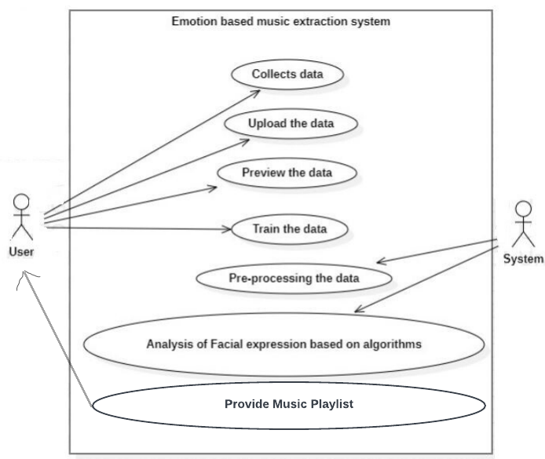

Figure 2:Use Case Diagram

### 3.1.2. Non-Functional Requirements

Non-functional requirements of Emotion Based Music Recommendation System using neural network and content-based filtering algorithm refers to the features and qualities that define the overall performance of the system.

Some of the non-functional requirements of the project are listed below:

* **Performance:** To ensure a smooth listening experience, make sure the system reacts to user requests fast and offers recommendations with the least amount of lag.
* **Maintainability:** Create a system that is simple to maintain and update, making it easier to add new features and modifications.
* **Portability:** Users should be able to access the system from a range of devices by having it accessible on many platforms and situations. As long as the project satisfies its minimal configuration, it may be carried out in a variety of operating environments.
* **Accessibility:** For the purpose of enabling an inclusive experience for users with limitations, the system must comply with accessibility requirements.

## 3.2 Feasibility Analysis

An Emotion-Based Music Recommendation System feasibility study determines whether the idea is feasible. It examines if the instruments and technology required to identify musical emotions and recommend songs are accessible and affordable. It also tests the possibility of managing a large emotional music database. This study aids in determining if developing the system is worthwhile. It ensures that the system meets user needs and can be implemented without significant issues or expenses. So, we make sure the idea is both solid and feasible before developing the system. The feasibility analysis can be done using various factors.

### 3.2.1 Technical Feasibility

As for the developer perspective, implementing this system requires a huge dataset for training and testing the model. These datasets are freely available on KAGGLE. Analyzing and categorizing emotion based on current user's facial feature is done using CNN. Once the system extracts the facial feature of user it suggests music from the music library, Spotipy. It also needs a user interface to capture and interpret user emotions which is easily implemented using HTML, CSS, and JS.

As a user it is required to make a use of few resources to use the system. Firstly, a computer with internet access to interact with the music repository of the system is required. Secondly, the system requires access to the camera of user's device to capture image. In terms of CPU, a modern processor with dual or quad core configuration should be sufficient. Additionally, minimum memory of 4 GB and storage not less than 10 GB is sufficient for the user to make use of the system. However, these are rough estimates and the performance of the system may vary according to GPU, internet bandwidth, and OS.

### 3.2.2 Operational Feasibility

An emotion-based music recommendation system's operational viability analyses how well it can be implemented into current processes. It evaluates how well the workflow, procedures, and resources of the system match. Operational viability also takes into account the system's simplicity of use and support requirements for effective daily operation. We can guarantee that the system can be smoothly integrated into their surroundings by carrying out this study. It provides a workable solution that improves music selection based on users' emotions and is simple to operate and support in actual operations.

### 3.2.3 Economic Feasibility

The system's economic feasibility assesses the project's economic sustainability. It involves determining the development, maintenance, and operational expenses in relation to the expected gains. It offers a financially sensible way to improve music suggestions based on users' feelings and assists project in determining if the method is economically justified. The project is financially feasible as minimum budget resources are required to build the system.

### 3.2.4 Schedule

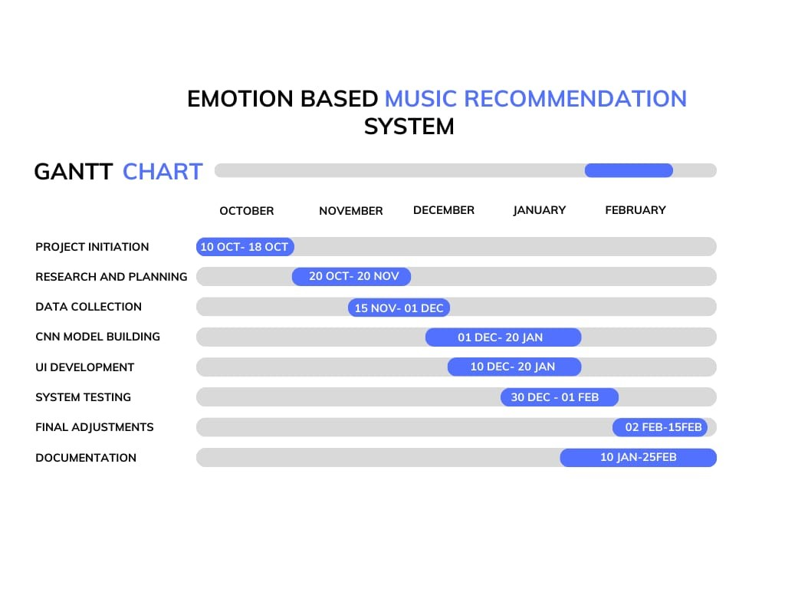

Figure 3:Gantt Chart

# CHAPTER-4

# System Design

## 4.1 System Design

Our system is designed based on Object Oriented Approach. Below figure illustrates the design of the system.

### 4.1.1 Class Diagram

A class diagram is a form of static structural diagram that shows the classes, attributes, methods, connections between classes, and constraints of a system. It does this by representing the structure of the system.

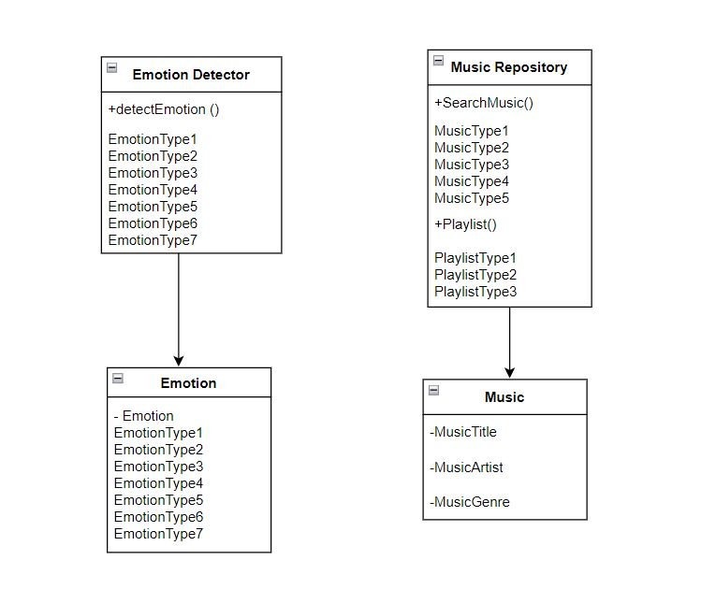

Figure 4:Class Diagram

### 4.1.2 Object Diagram

An object diagram is a kind of structural diagram that shows a particular instance of classes and their connections at a given moment in time. It displays the relationships between objects and their characteristics or values when a system or program is being executed. Using concrete instances and their interactions based on established classes, object diagrams offer a glimpse into the system's runtime state.

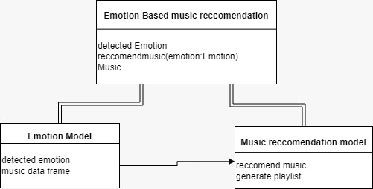

Figure 5:Object Diagram

### 4.1.3 State Diagram

A state diagram shows the behaviour of a system or object in terms of states, transitions between states, and events that cause these transitions. It is also referred to as a state machine diagram or a state chart diagram. It shows the range of possible states for an item or system as well as the circumstances under which a change in state occurs. State diagrams aid in the visualization and comprehension of how entities react to stimuli and change states over time by modelling the dynamic behaviour and control logic of systems.

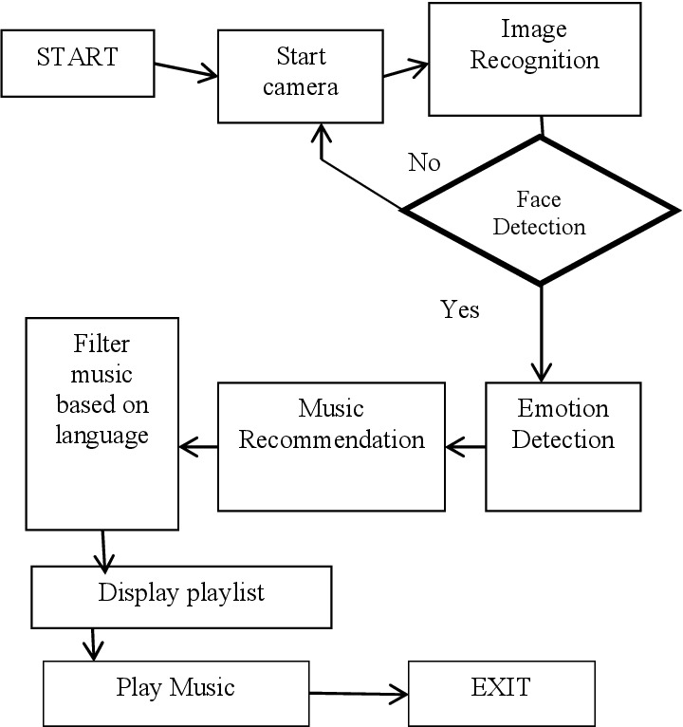

Figure 6:State Diagram

### 4.1.4 Sequence Diagram

A sequence diagram in UML shows the order in which messages are passed between objects or components to depict how they interact over time in a system. It's a useful tool for illustrating a system's control flow and execution sequence.

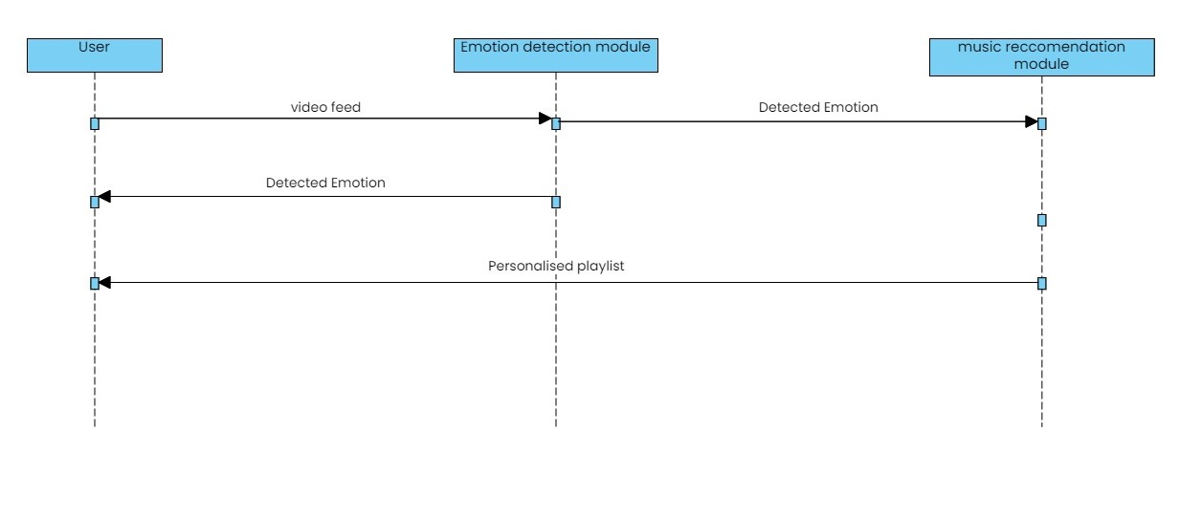

Figure 7:Sequence Diagram

### 4.1.5 Activity Diagram

An activity diagram represents processes, actions, choices, and concurrent activities to illustrate the flow of control inside a system. It is frequently used to simulate system behaviours, software workflows, and business processes.

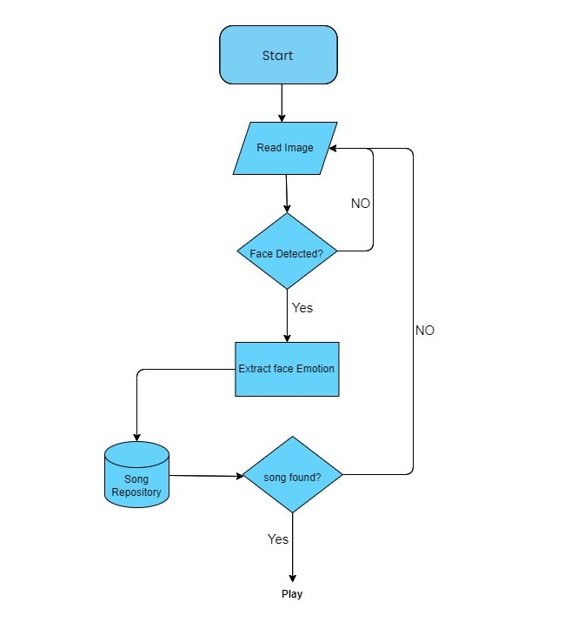

Figure 8:Activity Diagram

## 4.2 Algorithm details

Convolutional neural networks (CNNs) and Collaborative filtering are the two main algorithms that are essential to the operation of the emotion-based music recommendation system. Together, these algorithms can reliably predict the user's emotional state from visual input, and then they can suggest music that corresponds with the mood that has been identified. The algorithm can be outlined as:

* **Step-1: Initialize the System:**
* Input the previously trained face detection model from FER 2013 dataset.
* The pre-trained emotion recognition model should be loaded.
* Create the database of suggested music, categorized by emotion.
* **Step-2: Capture Video Stream:**
* Get instant access to the webcam feed.
* **Step-3: Detect facial data**
* Use the face detection model for every frame from the video stream to find faces in the picture.
* **Step-3: Emotion Recognition**
* Preprocess the image for each identified face such that it satisfies the model's input specifications for emotion recognition.
* Predict the emotion of the detected face(s) using the emotion recognition model.
* To identify the dominating emotion, aggregate emotion data over a predetermined period.
* **Step-4: Music Recommendation**
* Obtain a selection of suggested music tracks from the music repository that are associated with the primary emotion that was determined.
* **Step-5:** **Display Recommendations**
* Provide the user with a list of the suggested songs, together with information about the artist, track name, and play link.
* **Step-6: Iterate**
* Keep processing video frames in real-time, dynamically changing the music recommendations and emotion identification based on the user's shifting emotional state.
* **Step-7: Termination**
* Give the user a way to close the application and stop the video broadcast.

### 4.2.3 Integration of CNNs and Collaborative Filtering

A smooth and customized user experience is ensured by the integration of CNNs for emotion recognition and collaborative filtering for music suggestion. The system uses collaborative filtering techniques to query the music library and produce a list of recommended tracks that align with the user's current emotional state after detecting the user's emotion. This process improves the user's overall experience with the system and elevates their mood.

# CHAPTER-5

# Implementation and Testing

## 5.1 Implementation

The actual coding of the project starts from this stage. Division of works are done and scheduled. The implementation phase is performed according to the collected requirements and need of the system. This phase is regularly monitored for the better user satisfaction. The data are understood thoroughly along with the algorithms used in the system.

### 5.1.1 Data Set Collection

Our emotion-based music recommendation system required careful track record selection, annotation, and moderation of a wide range of genres and emotional expressions. Strictly defined emotion categories were used, and human commentators used well-established psychological theories as a guide to classify recordings according to the dominating emotions. The dataset was enhanced with metadata, including artist and genre details, and ethical considerations guaranteed respect to copyright regulations and respect for content producers. The facial data set is extracted from FER-2013 data set which is available in KAGGLE and the music data set is extracted from Spotify music library using Spotipy.

### 5.1.2 Code Implementation

**Emotion Data:** A folder named EmotionData contains images for different emotions which is used to train a neural network. The data is extracted from FER-2013 data set which is available in KAGGLE. [Source: <https://www.kaggle.com/datasets/msambare/fer2013>]

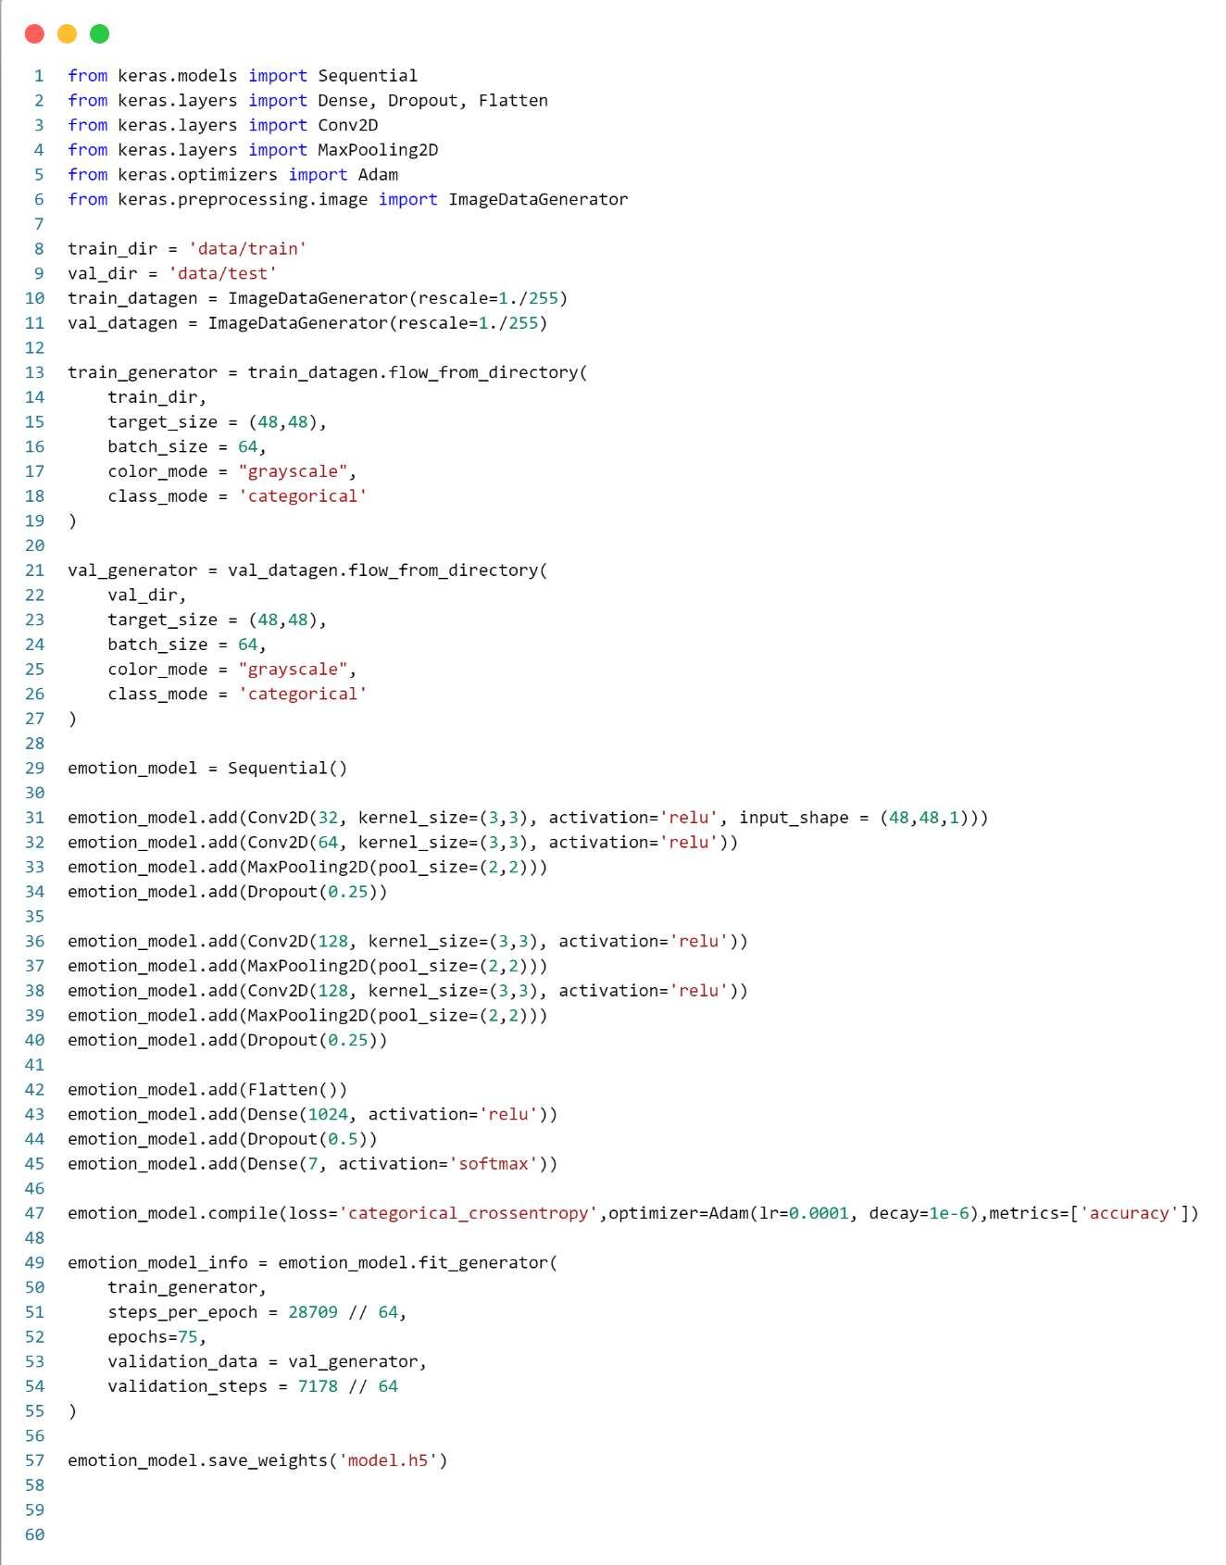

Figure 11: Emotion Recognition Model Code

**Musical Data:** A csv file contains musical data for each emotion. The file contains data for music name, album, artist, music player and cover image. Based on the emotion of the user, a suitable music for users’ emotion is played. The music data set is extracted from Spotify music library using Spotipy.

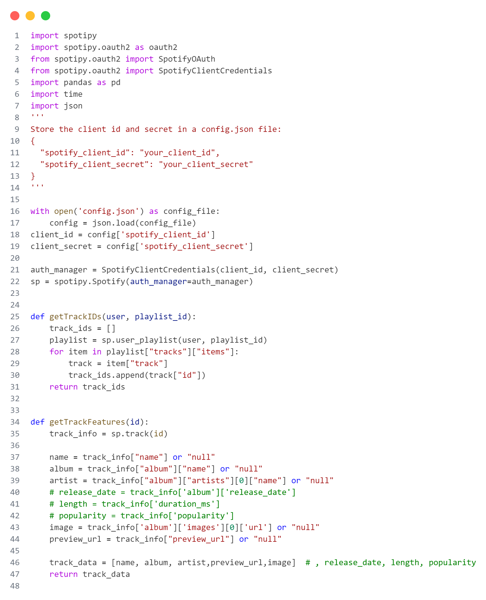

Figure 12: Music Recommendation Code

### 5.1.3 Data Tables

The data tables are given below:

Table 1: Music_Table.csv

|  |  |
| --- | --- |
| Field | Field type |
| Name | VARCHAR [50] |
| Album | VARCHAR [50] |
| Artist | VARCHAR [50] |
| Link | VARCHAR [100] |
| Image | VARBINARY |

Table 2: Emotion_Table.csv

|  |  |
| --- | --- |
| Emotion | Music Type |
| Happiness | Upbeat tempo, major key, lively instrumentation, positive lyrics |
| Sadness | Slow tempo, minor key, melancholic melodies, introspective lyrics |
| Angry | Aggressive instrumentation, distorted guitars, powerful vocals, intense lyrics |
| Surprised | Fast tempo, dynamic instrumentation, intense vocals, energetic rhythm |
| Disgust | Gentle tempo, soft instrumentation, soothing melodies, peaceful ambiance |

### 5.1.4 Tools Used

**Hardware Configuration**

The following are the hardware required for the implementation of the system:

* Personal Computers
* Processor type: Intel
* 4GB RAM or above
* Minimum HDD is applicable

**Software Configuration**

The following are the software required for the implementation of the system:

* Operating system: Windows 7 or higher
* Programming language: Python, HTML, CSS
* IDE: Visual Studio Code
* Camera or visual input device

**CASE Tools**

The following are the CASE tools required for the implementation of the system:

* UML modeling tools: draw.io, lucid chart
* Version control System: Git, GitHub
* Documentation Tool: Microsoft Word
* Collaboration and Communication Tools: MS Teams, WhatsApp

## 5.2 Testing

Testing is the process of examining a software program or system to find flaws or defects and to ensure that it fulfills the requirements and quality standards. It entails running a software or system in order to detect bugs, faults, or other problems and ensuring that it operates as planned. Functional testing, non-functional testing, manual testing, and automated testing are all examples of testing. Non-functional testing assesses performance, security, usability, and other quality factors, whereas functional testing evaluates the functionality of the software system. Manual testing requires human interaction to test the system, whereas automated testing uses tools and software to test the system. Testing is an important aspect of the software development life cycle (SDLC) since it aids in the early detection of flaws and mistakes and guarantees that the program fulfills the user's needs and expectations. Testing improves the quality and dependability of software while lowering the risk of failure and downtime.

## 5.3 Types of Testing

The types of testing used in this project are:

1. Unit Testing
2. System Testing

### 5.3.1 Unit Testing

During unit testing, each unit or component of a software program is tested separately to make sure it operates as intended. We perform unit tests for convolution neural networks in this system.

Table 3:Unit Testing

|  |  |  |  |  |  |  |
| --- | --- | --- | --- | --- | --- | --- |
| **ID** | **Test Scenario** | **Test Case** | **Test Step** | **Expected Result** | **Actual Result** | **Status** |
| T001 | Verify Button Functionality | To check whether the button is  clickable or not | * Open the   Application.     * Click home   Button. | User should be  redirected  to the main page | User gets redirected to  the main page | TRUE |
| T002 | Verify Button Functionality | To check whether the button is  clickable or not | * Open the   Application.     * Click home * Button. | User should be  redirected  to the main page | User gets redirected to  the main page | FALSE |
| T003 | Verify Button Functionality | To check whether the button is  clickable or not | * Open the   Application.     * Click home   Button. | User should be  redirected  to the main page | User gets redirected to  the main page | TRUE |

### 5.3.2 System Testing

System testing for an Emotion Based Music Recommendation system ensures that its components cooperate in order to detect emotions and recommend music accurately. This involves verifying the precision of emotion detection, the applicability of music recommendations, and the smooth operation of user interactions. The objective of system testing in our project is to make sure that the system performs properly and offers a positive user experience by identifying and fixing any integration, data management, and usability problems.

Table 4: System Testing

|  |  |  |  |  |  |  |
| --- | --- | --- | --- | --- | --- | --- |
| **ID** | **Test Scenario** | **Test Case** | **Test Step** | **Expected Result** | **Actual Result** | **Status** |
| T001 | Verify camera Functionality | To check whether it  opens the camera | * Open the   Application   * Go to the start page. | A div containing video feed must be loaded | A div containing video feed is loaded | TRUE |
| T002 | Verify facial emotion detection functionality | To check whether the model predicts the facial emotion of a user. | * Go to the start page. * Click on generate playlist. | Next page should be loaded with  the facial emotion detected | Page is loaded with correct facial expression predicted by model | TRUE |
| T003 | Verify Music playlist generation functionality | To check whether it  generates the playlist | * Open the   Application’s start tab   * Click on the generate Playlist button. | Next page should be loaded with  the generated playlist | Generated playlist is displayed with proper details. | TRUE |
| T004 | Verify Music Playback Functionality | To check whether the music is played properly | * Click on generate playlist. * Click on play button. | Music should be played. | Music is played when clicked on play button. | TRUE |

# CHAPTER-6

# Conclusion and Future Recommendation

## 6.1 Conclusion

Our study explores many approaches to improve user happiness and recommendation accuracy for emotion-based music recommendation systems. We investigate collaborative and CNNs recommendation systems through our research. We also discuss how neural network embedding methods may be used to improve these systems, improving recommendation accuracy and personalization.

Thus, our study emphasizes how important it is to investigate different strategies for recommendation engines. Through the synthesis of several methodologies, our goal is to create a collaborative engine that optimizes the advantages of numerous approaches while minimizing the drawbacks of each one. Although there may be disadvantages to using separate techniques when building music recommendation systems, combining these approaches should provide consumers with carefully chosen music selections that align with their moods and test. According to the user preference this system is able to provide the better music recommendation to the users without any delaying.

## 6.2 Future Recommendation

In this recommendation system different ideas can be added in the future. Some of the recommendation for the future are listed below:

* Our own database can be added.
* Music based on different languages can be added in the database.
* Accuracy of the model can be measured and improved.
* The music can be recommended to the user based on the currently playing music.

# References

|  |  |
| --- | --- |
| [1] | H. I. James, "EMOTION BASED MUSIC RECOMMENDATION SYSTEM," *(IRJET),* vol. 06, no. 03, pp. 2096-2101, 2019. |
| [2] | M. Vani, "EMOTION BASED MUSIC RECOMMENDATION SYSTEM," *IJCRT,* vol. 10, no. 6 June, pp. h697-h701, 2022. |
| [3] | A. Phaneendra, "EMUSE – AN EMOTION BASED MUSIC RECOMMENDATION SYSTEM," *IRMETS,* vol. 04, no. 05, pp. 4159-4163, 2022. |
| [4] | U. Gaikwad, "EMOTION BASED MUSIC RECOMMENDATION SYSTEM," *IJCRT,* vol. 11, no. 05, pp. K865-K876, 2023. |
| [5] | S. L. Shubham Kulkarni, "FACIAL EMOTION BASED MUSIC RECOMMENDATION SYSTEM," *IJNRD,* vol. 08, no. 05, pp. d725-d729, 2023. |
| [6] | S. Katkuri, "Emotion Based Music Recommendation System," *IJERT,* vol. 12, no. 05, 2023. |
| [7] | G.Tirumala, "Emotion Based Musicc Recommendation System," *JES,* vol. 14, no. 04, pp. 547-551, 2023. |

# APPENDIX

**Screenshots:**

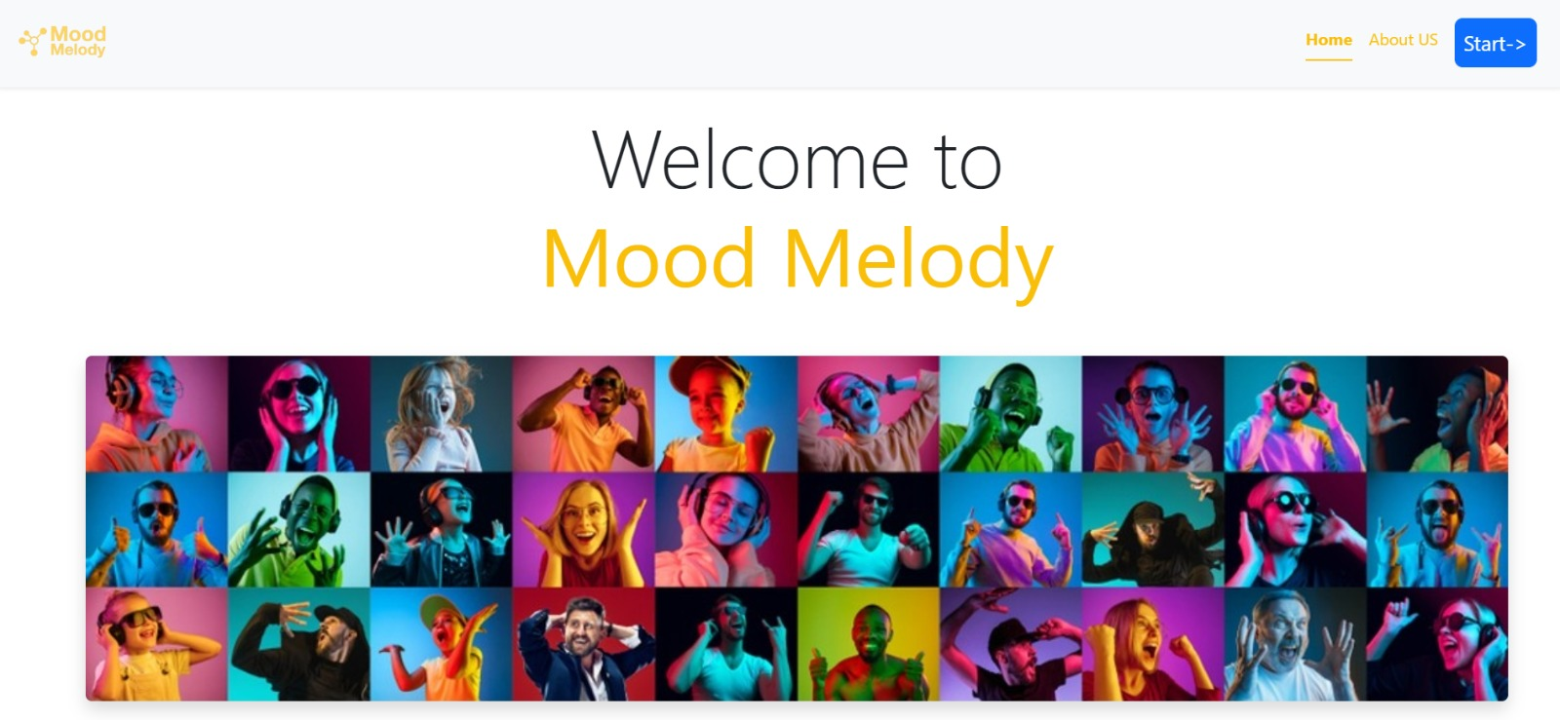

Figure 13:Home Page

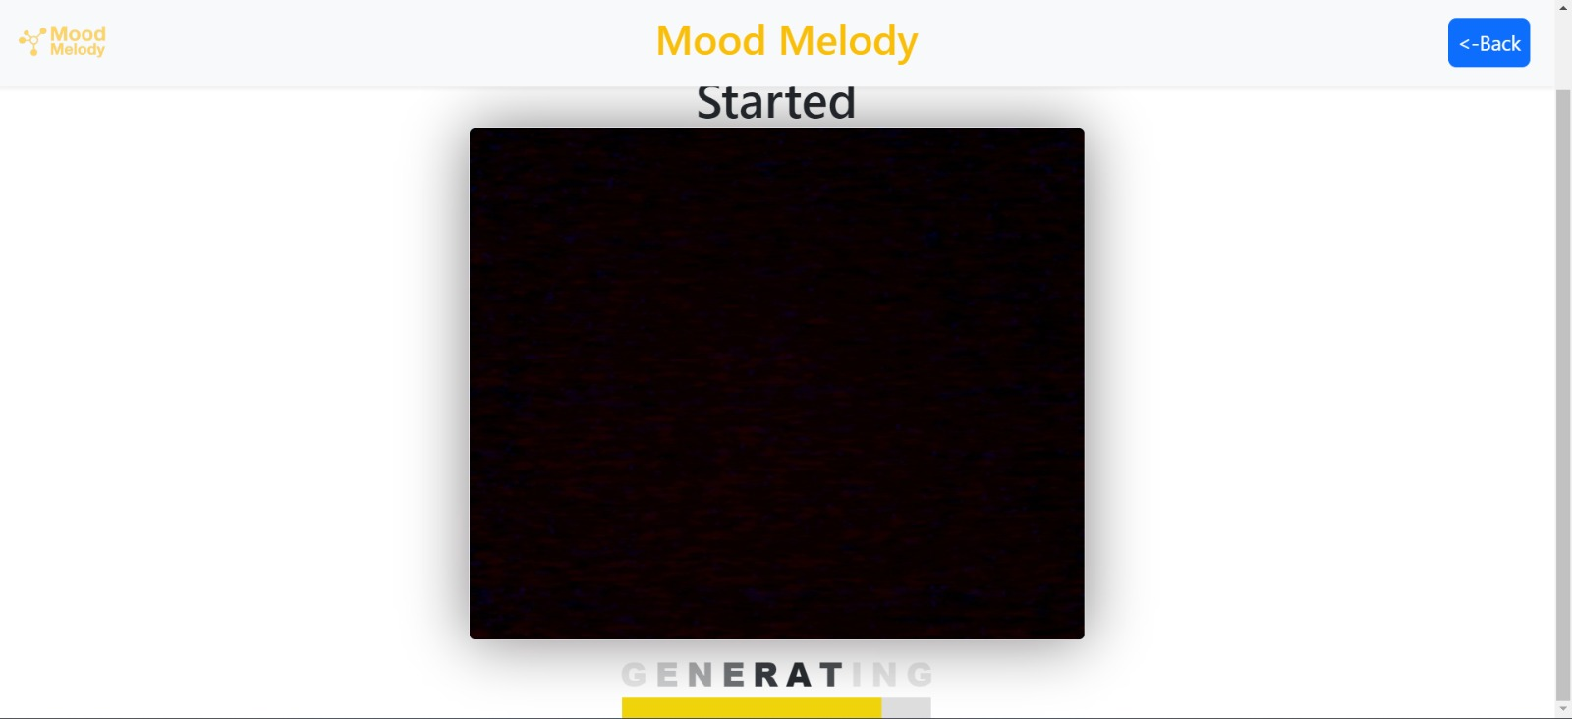

Figure 14:Start Page

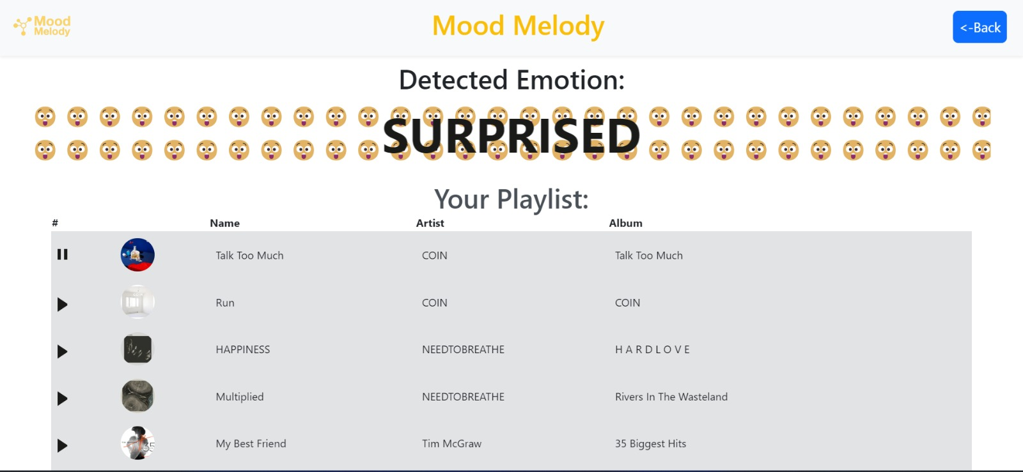

Figure 15:Music Recommendation Page

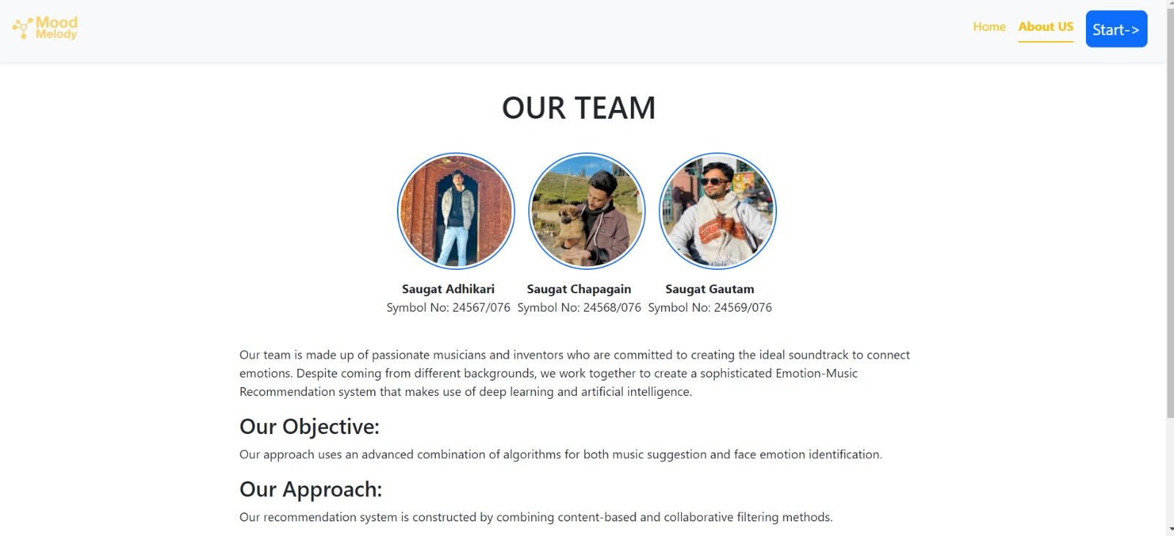

Figure 16:About Us Page